Churn Prediction
- Objective
The objective of this project is to develop a binary classification model capable of predicting customer churn in a telecommunications company. This type of prediction helps identify customers who are likely to leave the company, enabling strategies and improved business decision-making.

- Methodology
In this project we have followed a modular design, which can be seen below in the UML class diagram (each class is responsible for a specific stage of the pipeline).

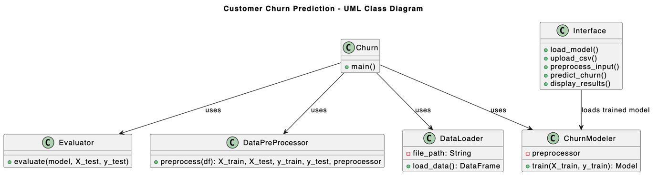
(Figure 1: UML Class Diagram)

The Churn class controls the overall process and ensures that each step is executed in the correct order. The data is first loaded and cleaned by the DataLoader class, which removes missing values and fixes incorrect data formats. The DataPreProcessor class prepares the data so that it can be used by the model. It transforms text information into numbers, adjusts numerical values to a similar scale, and divides the data into training and test sets while keeping a similar proportion of churn and non-churn customers.

The ChurnModeler class is responsible for training the prediction model. It builds a Random Forest model and adjusts it to work well even when the number of churn and non-churn customers is not balanced. The Evaluator class then checks how well the model performs by calculating evaluation results and showing visual graphs. Finally, the trained model is used by the Interface class to predict churn for new customers through a graphical user interface, without retraining the model.

- Results
The trained model achieves an accuracy of about 74%, which means that it correctly predicts the churn status for most customers. The F1-score of 0.61 shows that the model has a good balance between identifying customers who will churn and avoiding incorrect churn predictions. The ROC-AUC value of 0.83 indicates that the model is effective at distinguishing between customers who are likely to leave and those who are likely to stay.

The confusion matrix helps to understand how the model makes its predictions. It shows how many customers were correctly predicted as churners or non-churners, as well as the number of incorrect predictions. The results show that the model can identify many customers who are at risk of leaving, which is important for churn prediction. The ROC curve further supports these results by showing that the model performs well across different decision thresholds.

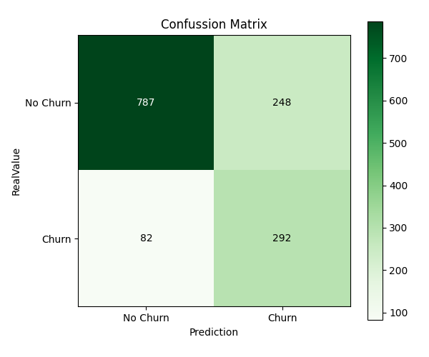

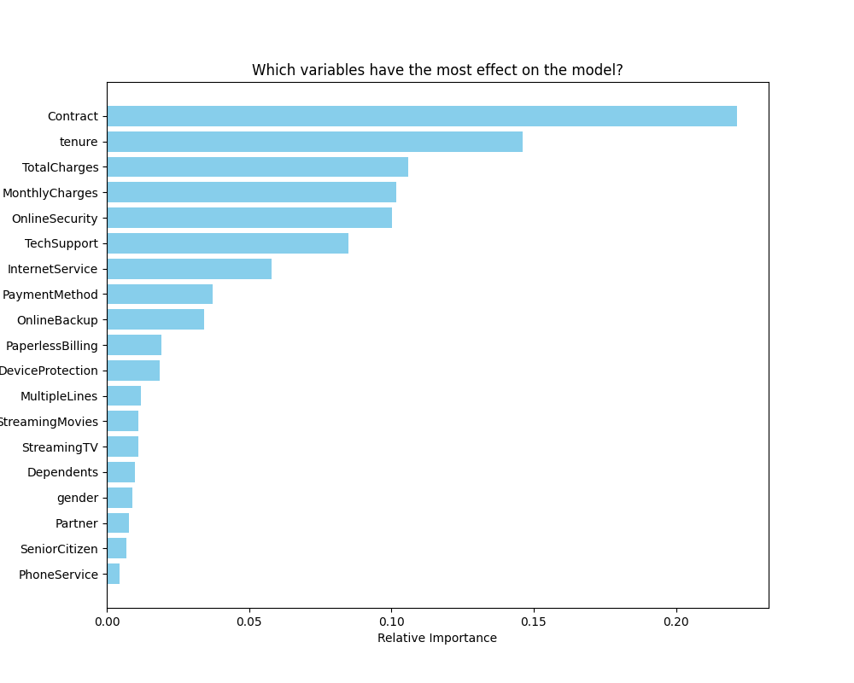

- Business Conclusion
From a business perspective, this churn prediction system provides important insights that can support customer retention strategies. By identifying customers who are likely to leave, the company can reach out to them and try to keep them by offering better support or more suitable contract options.

The modular architecture used in this project and shown in the UML class diagram ensures that the system is maintainable and extensible, allowing future improvements. Overall, the model works well, and the interface is easy to use, which makes the system useful in real situations and helps companies reduce the number of customers who leave.

- Running Instructions
First, open the Python project on a code editor of your liking. In our case we are using VS Code.
After the virtual environment (venv) is already started (if it isn`t use this command inside MachineLearning Project directory: source venv/bin/activate), we can run our project.
First thing we want to create is our “pkl” files which store both our prediction model and the features names we used to train our model. Without these files, the trained model could not be used outside our enviroment.
To create these two files, type on the terminal the next command: “python3 App.py”
After running App.py the two necessary “pkl” files will have been created and in addition we get to see the confusion matrix from the model and the relative importance table, which explains the relative importance of every variable on the prediction model.
Now, to run the streamlit implementation we need to type this command on the terminal: “python3 -m streamlit run Interface.py” (of course we are doing all of this inside our “Project” directory, where all our code is).
Once we are inside our Streamlit app, we can select the client’s data from which we want to predict if it’ll Churn or not. To do this we use the sidebar on the left side of the window.
After we are done selecting the data, we press the clickable button “Calculate Churn Risk” and we will see the result of the prediction (Whether the client will churn or not).

